🔹 FINAL MENU STRUCTURE (HEADER)
Products
- Wrapping Machines
- Pallet Stretch Wrapping Machines
  - LPW100S
  - LPW100F
  - LPW200MT
  - LPW300TP
  - LPW100AS
  - LPW100AF
  - LPW200AMT
  - LPW300ATP
  - LPW100ARA
  - LPW200ART
  - LPW300AO
- Box Stretch Wrapping Machines
  - LPW100SB
  - LPW200FB
  - LPW300TPB
- Orbit Stretch Wrapping Machines
  - LPW100AHO
  - LPW200AVC
  - LPW200AHC
  - LPW300AR
- Taping Machines
- Standard Taping Machines
  - LPT100M
  - LPT200S
  - LPT300F
- Autonomous Taping Machines
  - LPT100ARS
  - LPT200ARF
  - LPT300ARC
  - LPT400ARCE
- CONVEYOR
- Belt Conveyor
  - LPC100BC
- Cross Transfer Conveyor
  - LPC100CT
- Flexible Roller Conveyor
  - LPC100FR
- Pallet Turntable Conveyor
  - LPC100PT
- Power Roller Conveyor
  - LPC100PR

- Lift Auto Door Mechanism
- JLT – S SERIERS
  - Centre Opening Car Header
  - Centre Opening Landing Header
  - Telescopic Opening Car Header
  - Telescopic Opening Landing Header
- JLT – F SERIERS
  - Centre Opening Car Header
  - Centre Opening Landing Header
  - Telescopic Opening Car Header
  - Telescopic Opening Landing Header
- JLT – Parts
  - S SERIERS
  - F SERIERS

PALLET STRETCH WRAPPING MACHINE
LYNOPACK LPW100S
Manual Adjust Stretch Wrapping Machine
LYNOPACK LPW100S is a semi-automatic manual adjust stretch wrapping machine designed for secure and economical pallet wrapping. It is an ideal solution for warehouses, logistics centers, and small to medium manufacturing units.
The machine allows manual adjustment of film tension and wrapping height, ensuring stable load containment
it easy to operate on the shop floor.
LPW100S is suitable for wrapping palletized loads of different sizes using standard stretch film. The sturdy construction ensures long service life, while the simple operating mechanism makes it user-friendly and low maintenance.
Key Features:
- Manual film tension adjustment
- Height adjustable mast
- Smooth film carriage movement
- Heavy-duty base
- Easy operation, no power required
Applications: Warehousing, FMCG, pharmaceuticals,
logistics, export packaging.

LPW100F
Pallet Stretch Wrapping Machine
The LYNOPACK LPW100F is a pallet stretch wrapping machine designed for reliable and consistent pallet wrapping applications. It is suitable for intensive day-to-day operations while ensuring stable load containment and optimized stretch film usage.
Built with a robust structure and user-friendly operation, LPW100F provides precise control over the wrapping process, helping improve packaging efficiency and reduce film wastage. The machine is ideal for warehouses, logistics centers, and manufacturing units looking for a dependable pallet wrapping solution.
Designed to meet modern packaging requirements, the LPW100F ensures better load safety during transportation while saving time, labor, and packaging resources.

LYNOPACAK LPW200MT
M-Type Pallet Stretch Wrapping Machine
The LPW200MT M-Type Pallet Stretch Wrapping Machine is designed for effortless pallet loading and unloading using a forklift or manual stacker. Its unique “M” shaped turntable allows pallets to enter the machine directly without lifting, reducing manual handling.
Key Features:
- Easy Loading/Unloading: M-shaped cutout ensures smooth entry for pallet jacks or stackers.
- Semi-Automatic/Automatic Operation: Simply place the pallet, and the machine wraps it efficiently.
- Safety & Stability: Photo-eye sensors detect pallet height while the stretch film secures the load for safe transport and storage.
- Material Efficiency: Power pre-stretch unit optimizes film use, reducing material costs by up to 250%.
How It Works:
- Place the pallet on the M-shaped turntable using a forklift or pallet jack.
- Attach the film or let the automated system handle it.
- The turntable rotates while the film carriage moves up and down, wrapping the pallet evenly.
- Film is cut and secured automatically or manually.
- Remove the wrapped pallet for transport.
The LPW200MT offers a reliable, efficient solution for industries seeking safe, continuous, and cost-effective pallet wrapping.

LYNOPACK LPW300TP
Top Press Pallet Stretch Wrapping Machine
The LPW300TP Top Press Pallet Stretch Wrapping Machine is specially designed to secure lightweight, loose, or uneven pallet loads with maximum stability. It features a top press plate that applies controlled downward pressure during the wrapping cycle, preventing load shifting or toppling during handling and transportation.
Key Features:
- Top Press Plate: Pneumatically or hydraulically operated plate firmly holds the load from the top during wrapping.
- Automatic Operation: Automated film wrapping, cutting, and securing reduces manual labor and improves efficiency.
- High Load Stability: Compresses the load to eliminate gaps, ensuring tight and stable pallet wrapping.
- Protection: Stretch film provides excellent dust and moisture protection for stored or transported goods.
Working Principle:
The operator places the pallet on the turntable and starts the cycle.
The top press plate descends to secure the load.
The turntable rotates while the film carriage moves vertically, wrapping the pallet evenly.
After wrapping, the top press lifts and the pallet is ready for transport.
Applications:
Ideal for industries such as food & beverage, electronics, chemicals, pharmaceuticals, and building materials, where stable and secure pallet packaging is essential.
The LPW300TP delivers superior load integrity, safety, and automation, making it a reliable solution for professional pallet packaging operations.

LYNOPACK LPW100AS
Autonomous Semi Pallet Stretch Wrapping Machine
LYNOPACK LPW100AS is an advanced semi-automatic stretch wrapping machine designed for efficient, consistent, and secure pallet wrapping. Equipped with automatic film clamping and cutting, it reduces manual intervention and improves productivity, making it ideal for modern warehouses, logistics centers, and manufacturing units.
This model offers automatic wrapping cycles with precise film tension control, ensuring excellent load stability and uniform wrapping quality. Its user-friendly control system allows easy operation on the shop floor while maintaining high packaging efficiency.
The LPW100AS is suitable for wrapping palletized loads of various sizes using standard stretch film. Built with a robust structure, the machine ensures long service life, low maintenance, and reliable performance in demanding industrial environments.
Key Features:
- Automatic film clamping and cutting system
- Pre-set wrapping programs
- Adjustable wrapping height
- Smooth and stable film carriage movement
- Heavy-duty base construction
- User-friendly control panel
- Low maintenance and high operational efficiency
- Remote operated control system
Applications:
Warehousing, FMCG, pharmaceuticals, logistics, export packaging, and general manufacturing industries.

LYNOPACK LPW100AF
Autonomous Fully Pallet Stretch Wrapping Machine
LYNOPACK LPW100AF is an autonomous, fully automatic pallet stretch wrapping machine designed for maximum efficiency, consistency, and hands-free operation. Compared to the LPW100AS, this advanced model is equipped with an automatic film pasting system, which securely pastes the stretch film at the end of the wrapping cycle, ensuring a clean and professional finish without manual intervention.
The machine performs the complete wrapping process automatically—including film clamping, wrapping, cutting, and end-cycle film pasting—delivering superior load stability and reduced operator involvement. Its intelligent control system ensures precise film tension and uniform wrapping for pallets of varying sizes.
The LPW100AF is ideal for high-throughput packaging environments where speed, reliability, and consistent wrap quality are critical. Built with a heavy-duty structure, it ensures long service life, low maintenance, and dependable performance.
Key Features:
- Fully autonomous operation
- Automatic film clamping, cutting, and end-cycle film pasting
- Advanced control system for precise wrapping
- Adjustable wrapping height
- Smooth film carriage movement
- Heavy-duty base and robust construction
- Minimal operator intervention
- High productivity with consistent wrapping quality
Applications:
Warehousing, FMCG, pharmaceuticals, logistics, export packaging, food & beverage, and manufacturing industries.

LYNOPACK LPW200AMT
Autonomous M-Type Pallet Stretch Wrapping Machine
The LYNOPACK LPW200AMT Autonomous M-Type Pallet Stretch Wrapping Machine is designed for effortless pallet loading and unloading using a forklift or manual stacker. Its unique “M”-shaped turntable allows direct pallet entry without lifting, significantly reducing manual handling and improving operator safety.
This advanced model features fully autonomous operation, including automatic film clamping, cutting, and end-cycle film pasting, ensuring a clean, secure, and professional wrap finish without manual intervention.
Key Features:
- Easy Loading / Unloading: M-shaped cutout enables smooth entry for pallet jacks and stackers
- Fully Autonomous Operation: Automatic wrapping cycle with minimal operator involvement
- Auto Film Clamping, Cutting & Pasting: Ensures proper film start and secure film sealing at the end of the cycle
- Safety & Stability: Photo-eye sensors automatically detect pallet height for accurate wrapping
- Material Efficiency: Power pre-stretch unit optimizes stretch film usage, reducing material costs by up to 250%
- Consistent Wrapping Quality: Uniform tension and tight load containment for safe transport and storage
How It Works:
- Place the pallet on the M-shaped turntable using a forklift or pallet jack
- Start the cycle; the machine automatically clamps the film
- The turntable rotates while the film carriage moves vertically, wrapping the pallet evenly
- At the end of the cycle, the film is automatically cut and pasted securely
- Remove the wrapped pallet, ready for transport or storage
The LPW200AMT delivers a highly efficient, safe, and cost-effective pallet wrapping solution for industries requiring continuous operation with minimal manpower.

LYNOPACK LPW300ATP
Autonomous Top Press Pallet Stretch Wrapping Machine
The LYNOPACK LPW300ATP Autonomous Top Press Pallet Stretch Wrapping Machine is designed to secure lightweight, loose, or uneven pallet loads with maximum stability and fully hands-free operation. It combines a top press plate with fully autonomous stretch wrapping, ensuring superior load containment during handling and transportation.
This advanced model features automatic film clamping, cutting, and end-cycle film pasting, delivering a clean, secure wrap finish without manual intervention. The top press system applies controlled downward pressure throughout the wrapping cycle, preventing load shifting or toppling.
Key Features:
- Top Press Plate: Pneumatically or hydraulically operated plate firmly holds the load from the top during wrapping
- Fully Autonomous Operation: Complete automatic wrapping cycle with minimal operator involvement
- Auto Film Clamping, Cutting & Pasting: Ensures proper film start and secure film sealing at the end of the cycle
- High Load Stability: Compresses loads to eliminate gaps, ensuring tight and stable pallet wrapping
- Advanced Safety System: Photo-eye sensors automatically detect pallet height for precise wrapping
- Protection: Stretch film provides excellent dust and moisture protection during storage and transit
- Consistent Wrapping Quality: Uniform film tension for professional packaging results
Working Principle:
- The operator places the pallet on the turntable and starts the cycle
- The top press plate descends to securely hold the load
- The turntable rotates while the film carriage moves vertically, wrapping the pallet evenly
- At the end of the cycle, the film is automatically cut and pasted
- The top press lifts, and the wrapped pallet is ready for transport
Applications:
Ideal for food & beverage, electronics, chemicals, pharmaceuticals, building materials, logistics, and export packaging, where high stability and automation are required.
The LPW300ATP delivers maximum load integrity, safety, and productivity, making it a reliable and advanced solution for high-performance pallet packaging operations.

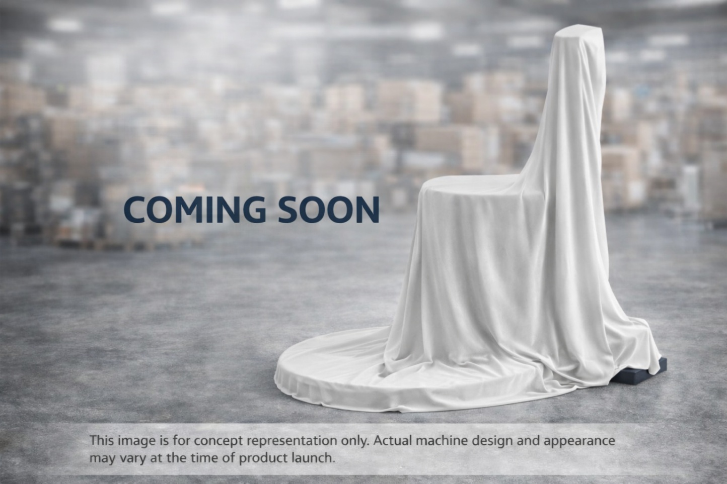

LYNOPACK LPW100ARA

Autonomous Rotary Arm Fully Automatic Pallet Stretch Wrapping Machine
The LYNOPACK LPW100ARA is an autonomous rotary arm pallet stretch wrapping machine designed for high-throughput, space-efficient, and fully automatic pallet packaging.
Unlike traditional turntable machines, the rotary arm rotates the film carriage around a stationary pallet, making it ideal for heavy, unstable, or very light loads that cannot be rotated safely.

Core Functionality
- Rotary Arm Wrapping System:
The wrapping arm rotates smoothly around the pallet while the load remains stationary, ensuring stable and uniform film application.
- Fully Automatic & Autonomous Operation:
Automatic film clamping, cutting, and secure tail pasting eliminate manual intervention and improve cycle consistency.
- No Pallet Rotation Required:
Ideal for fragile, heavy, or irregular loads that may topple on turntable-based machines.

Key Features
- Autonomous Operation: Auto film clamping, cutting, and end-of-cycle pasting
- Power Pre-Stretch Unit: Optimizes film usage and reduces stretch film consumption
- Photo-Eye Sensor: Automatically detects pallet height for precise wrapping
- PLC Controlled System: Ensures consistent performance and easy operation
- Heavy-Duty Rotary Arm: Designed for continuous industrial use
- Enhanced Safety: Integrated safety sensors and emergency stop system

Working Principle
- The pallet is positioned in the wrapping zone using a forklift or conveyor.
- The film is automatically clamped to the pallet base.
- The rotary arm rotates around the stationary load while the film carriage moves vertically.
- Stretch film is applied evenly with controlled tension for maximum load stability.
- At cycle completion, the film is automatically cut and securely pasted.
- The wrapped pallet is ready for transport or storage.

Applications
The LPW100ARA is widely used in:
- FMCG and food & beverage industries
- Pharmaceuticals and healthcare packaging
- Chemicals and building materials
- Export and logistics operations
- Heavy, fragile, or unstable pallet loads

Key Benefits
- Eliminates load instability caused by pallet rotation
- Suitable for high-speed and continuous packaging lines
- Reduces labor dependency and operational errors
- Ensures superior load containment and protection

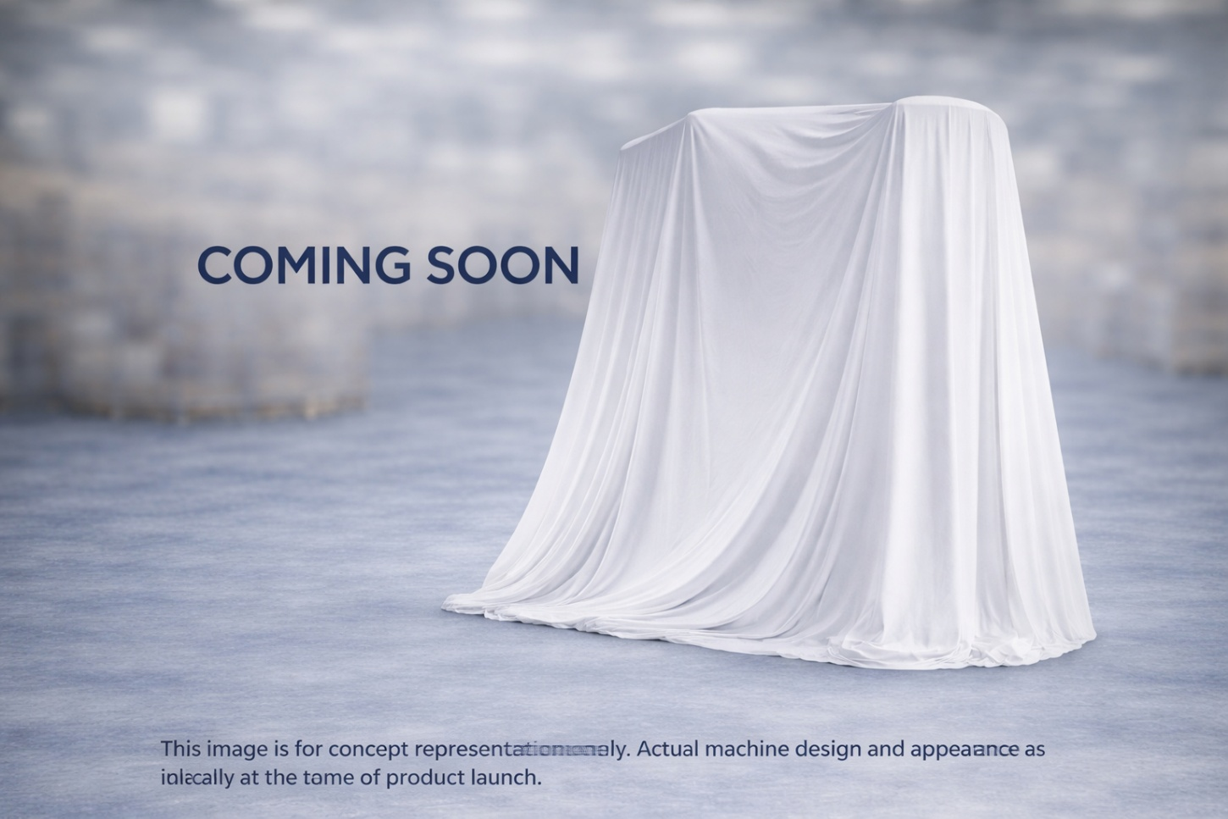

LYNOPACK LPW200ART

Autonomous Ring Type High-Speed Fully Automatic Pallet Stretch Wrapping Machine
The LYNOPACK LPW200ART is an autonomous ring type pallet stretch wrapping machine engineered for high-speed, continuous, and fully automatic pallet packaging operations.
Its advanced rotating ring technology enables extremely fast and consistent wrapping, making it ideal for high-volume production lines and automated logistics environments.

Core Functionality
- Ring Type Wrapping System:
A high-speed rotating ring carries the film carriage around a stationary pallet, ensuring uniform wrapping without rotating the load.
- Fully Automatic & Autonomous Operation:
Automatic film clamping, cutting, and secure end-of-cycle pasting eliminate manual handling and maximize productivity.
- Stationary Pallet Wrapping:
Heavy, unstable, or fragile pallets remain fixed during wrapping, ensuring superior load stability.

Key Features
- High-Speed Wrapping Performance: Designed for continuous, high-throughput pallet wrapping
- Power Pre-Stretch System: Optimizes film usage and significantly reduces material consumption
- PLC & HMI Control Panel: User-friendly operation with programmable wrapping cycles
- Automatic Height Detection: Photo-eye sensors adjust wrapping height precisely
- Heavy-Duty Ring Structure: Built for long-life industrial operation
- Advanced Safety System: Safety fencing, sensors, and emergency stops for operator protection

Working Principle
- The pallet is conveyed or positioned into the wrapping station.
- The film is automatically clamped to the pallet base.
- The rotating ring spins at high speed around the stationary pallet while the film carriage moves vertically.
- Stretch film is applied with controlled tension for maximum load containment.
- At the end of the cycle, the film is automatically cut and securely pasted.
- The wrapped pallet exits the machine, ready for storage or dispatch.

Applications
The LPW200ART is ideal for:
- High-volume FMCG and food & beverage plants
- Automated warehouses and distribution centers
- Export packaging operations
- Heavy, tall, or unstable pallet loads
- Fully automated conveyor-based packaging lines

Key Benefits
- Extremely high wrapping speed and throughput
- Zero load rotation ensures maximum stability
- Reduced film consumption and operational cost
- Seamless integration with automated production lines
- Minimal manual intervention and consistent wrap quality

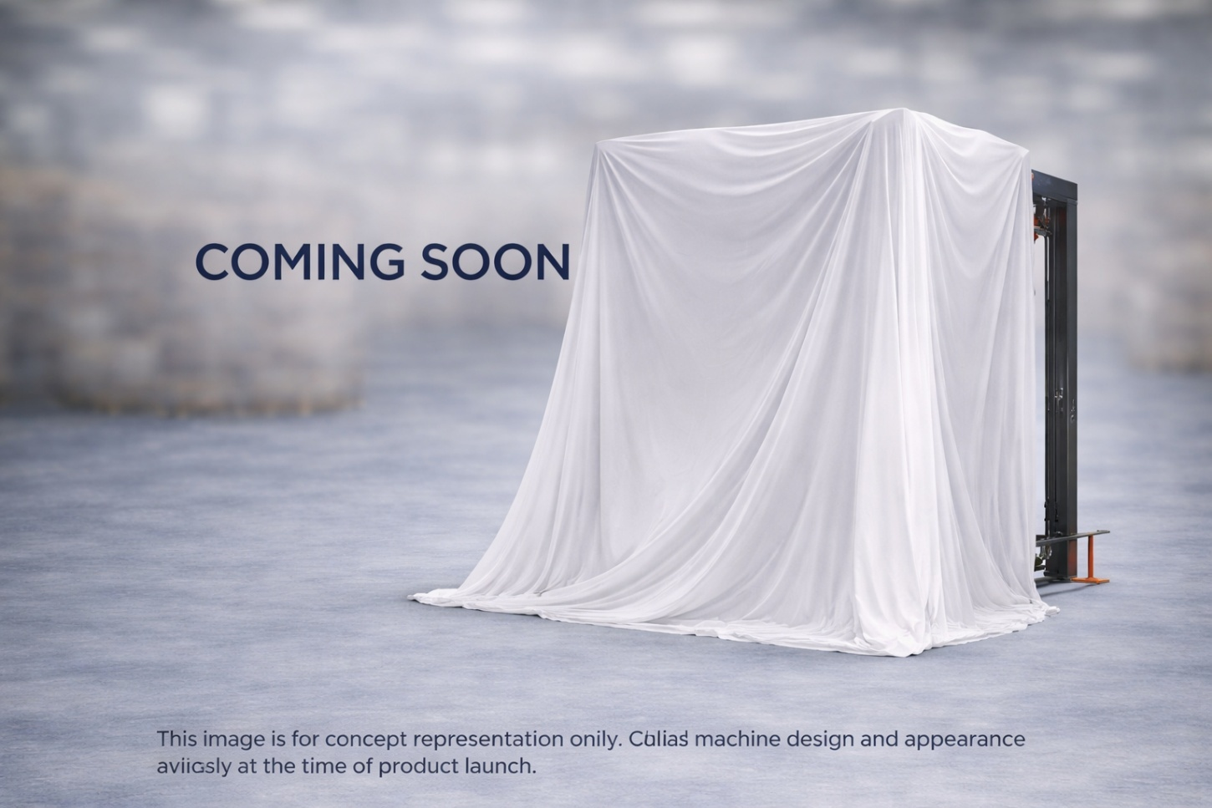

LYNOPACK LPW300AO

Autonomous Online Fully Automatic Pallet Stretch Wrapping Machine
The LYNOPACK LPW300AO is an autonomous online pallet stretch wrapping machine designed for fully automatic, continuous, and high-efficiency pallet packaging.
This model is engineered to operate inline with conveyor systems, eliminating manual pallet handling and making it ideal for modern automated production and logistics facilities.

Core Functionality
- Online Inline Wrapping System:
The machine integrates directly into conveyor lines, allowing pallets to enter, wrap, and exit automatically without forklift intervention.
- Fully Automatic & Autonomous Operation:
Automatic film clamping, cutting, and secure end-of-cycle pasting ensure consistent wrapping with zero manual input.
- Continuous Production Flow:
Designed for nonstop operation, supporting high-volume packaging environments.

Key Features
- Power Pre-Stretch Film Unit: Reduces stretch film consumption while maintaining strong load containment
- PLC & HMI Control System: Enables programmable wrapping cycles and easy operation
- Automatic Pallet Height Detection: Photo-eye sensors ensure accurate wrapping for varying pallet heights
- Heavy-Duty Industrial Construction: Built for long-term, continuous use
- Advanced Safety System: Safety guards, interlocks, and emergency stop functions
- Seamless Automation Integration: Compatible with conveyors, palletizers, and warehouse automation systems

Working Principle
- Pallets arrive automatically via conveyor into the wrapping station.
- The film is automatically clamped at the pallet base.
- The wrapping system applies stretch film uniformly around the pallet while it remains in position.
- After wrapping, the film is automatically cut and securely pasted.
- The wrapped pallet exits the machine and continues along the conveyor line.

Applications
The LPW300AO is widely used in:
- FMCG and food & beverage manufacturing plants
- Pharmaceutical and chemical industries
- Automated warehouses and distribution centers
- Export-oriented packaging lines
- High-throughput production environments

Key Benefits
- Eliminates manual pallet handling and wrapping labor
- Ensures consistent, high-quality pallet wrapping
- Increases line efficiency and packaging throughput
- Reduces film usage and operating costs
- Ideal for fully automated packaging lines

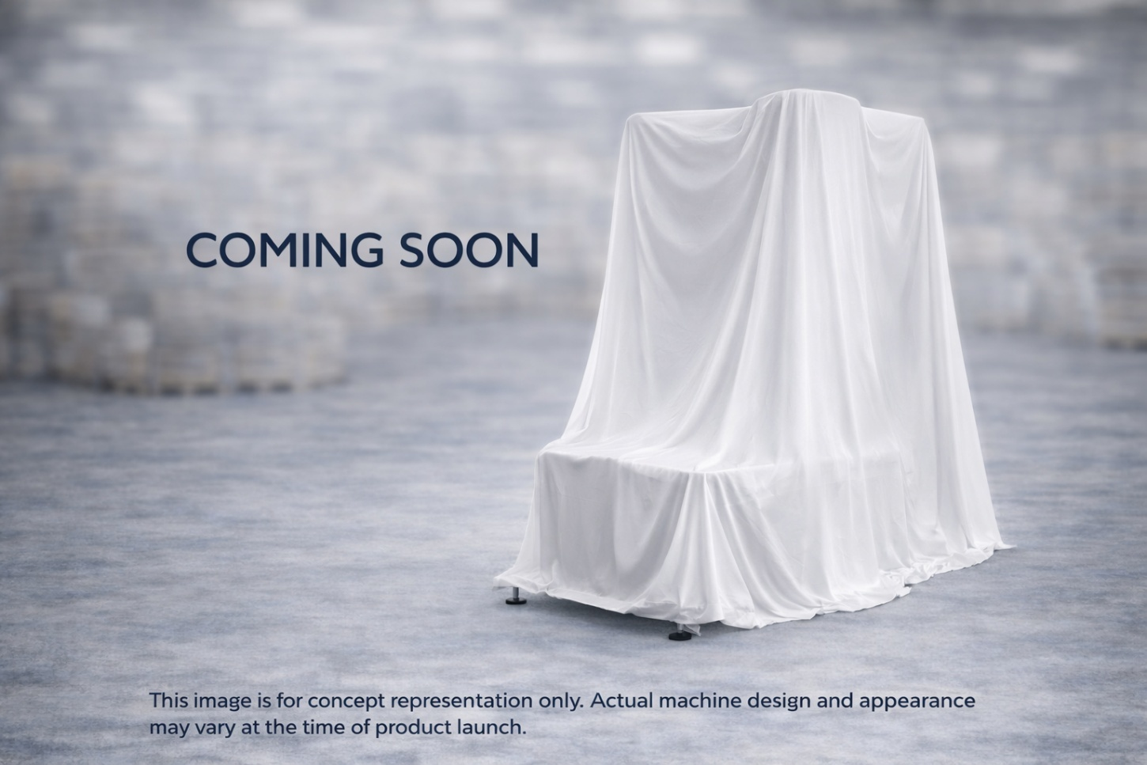

BOX WRAPPING MACHINE

LYNOPACK LPW100SB

Semi-Automatic Box Stretch Wrapping Machine
The LYNOPACK LPW100SB is a semi-automatic box stretch wrapping machine designed as a cost-effective and compact packaging solution for lightweight and uniform cartons.
This model is engineered without a pre-stretch unit and without height travel, making it ideal for businesses seeking simple operation, low power consumption, and reliable wrapping performance.

Core Functionality
- Wrapping-Only Operation:
The box is placed on the rotating turntable while the stretch film is applied at a fixed height, ensuring consistent wrapping for standard box sizes.
- No Pre-Stretch System:
Film stretching is achieved through manual tension control, using resistance from the film roll instead of a motorized pre-stretch mechanism.
- Fixed Film Carriage (No Height Travel):
The film dispenser remains at a fixed position, making the machine best suited for box heights equal to or less than the film roll width.

Key Technical Features
- Adjustable turntable speed via VFD control
- Manual film tension adjustment
- Heavy-duty turntable for smooth rotation
- Compact footprint for easy installation
- Low power consumption with single-phase 220V supply

Applications
The LPW100SB is ideal for:
- Lightweight cartons and boxes
- Garments and textile packaging
- Small electronics and accessories
- Pharmaceutical and cosmetic cartons
- Low-volume packaging operations (20–40 boxes per hour)

Ideal For
Small businesses, warehouses, and logistics operations that require a simple, economical, and reliable box wrapping solution without complex automation.

LYNOPACK LPW200FB

Fully Automatic Box Stretch Wrapping Machine
The LYNOPACK LPW200FB is a fully automatic box stretch wrapping machine designed for high-efficiency, uniform, and professional carton wrapping.
Equipped with a power pre-stretch unit and automatic up-down film carriage movement, this model ensures consistent wrapping quality, improved load stability, and reduced stretch film consumption.

Core Functionality
- Fully Automatic Wrapping Operation:
Automatic film clamping, wrapping, cutting, and secure end-cycle sealing ensure hands-free operation and high productivity.
- Power Pre-Stretch Unit:
Motorized pre-stretch system optimizes film usage, delivering strong load containment while significantly reducing material cost.
- Automatic Up-Down Film Carriage:
The film carriage moves vertically during the wrapping cycle, allowing efficient wrapping of boxes with different heights.

Key Features
- Fully automatic operation with minimal operator intervention
- Power pre-stretch system for reduced film consumption
- Automatic vertical (up-down) film carriage movement
- PLC controlled system with user-friendly HMI
- Consistent and uniform wrapping tension
- Heavy-duty construction for continuous operation
- Low maintenance and reliable performance

Working Principle
- The box is placed on the turntable or conveyed into the wrapping station.
- The film is automatically clamped at the base of the box.
- The turntable rotates while the film carriage moves up and down, wrapping the box evenly.
- Stretch film is applied with controlled tension using the pre-stretch unit.
- At the end of the cycle, the film is automatically cut and securely sealed.
- The wrapped box is ready for storage or dispatch.

Applications
The LPW200FB is ideal for:
- Carton and box packaging operations
- FMCG and food & beverage industries
- Pharmaceuticals and cosmetics
- Electronics and consumer goods
- Warehousing, logistics, and export packaging

Key Benefits
- Professional and uniform box wrapping
- Reduced stretch film usage and operating cost
- Supports different box heights
- Improved product protection against dust and moisture
- Suitable for medium to high-volume packaging operations

LYNOPACK LPW300TPB

Top Press Box Stretch Wrapping Machine
The LYNOPACK LPW300TPB is a top press box stretch wrapping machine designed to securely wrap lightweight, loose, or unstable boxes with maximum stability.
It features a top press system that applies controlled downward pressure during the wrapping cycle, preventing box movement and ensuring a tight, uniform wrap.

Core Functionality
- Top Press Stabilization:
The top press plate holds the box firmly from above while wrapping, eliminating shifting or tilting during rotation.
- Consistent Box Wrapping:
Ensures uniform stretch film application, improving load stability and professional packaging quality.
- Enhanced Protection:
Stretch film provides excellent protection against dust, moisture, and handling damage.

Key Features
- Pneumatic or hydraulic top press plate for stable box positioning
- Automatic wrapping cycle for consistent results
- Uniform film tension control for tight wrapping
- Suitable for lightweight and irregular boxes
- Heavy-duty base construction for smooth operation
- User-friendly control panel
- Low maintenance and reliable performance

Working Principle
- The box is placed on the turntable.
- The top press plate descends to secure the box.
- The turntable rotates while stretch film is applied evenly around the box.
- After wrapping, the top press plate lifts.
- The wrapped box is ready for storage or dispatch.

Applications
The LPW300TPB is ideal for:
- Lightweight cartons and boxes
- FMCG and food packaging
- Pharmaceuticals and cosmetics
- Electronics and consumer goods
- Warehousing, logistics, and export packaging

Key Benefits
- Prevents box movement during wrapping
- Ensures tight, stable, and professional packaging
- Reduces product damage during handling
- Improves packaging efficiency and consistency

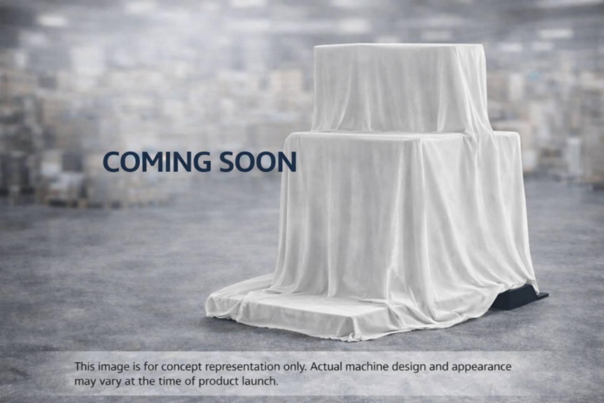

ORBIT STRETCH WRAPPING MACHINE

LYNOPACK LPW100AHO

Autonomous Horizontal Orbit Stretch Wrapping Machine
The LYNOPACK LPW100AHO is an autonomous horizontal orbit stretch wrapping machine designed for efficient, secure, and fully automatic wrapping of long, flat, or bundled products.
Unlike pallet wrapping machines, this model uses a horizontal orbital wrapping system, where stretch film is applied by a rotating ring while the product moves or remains positioned on a conveyor.

Core Functionality
- Horizontal Orbital Wrapping System:
A rotating ring carries the stretch film around the product horizontally, ensuring uniform wrapping along the entire length.
- Autonomous Fully Automatic Operation:
Automatic film clamping, cutting, and secure end-cycle sealing eliminate manual handling and ensure consistent wrapping quality.
- Continuous Flow Packaging:
Designed for inline operation, making it suitable for high-efficiency and continuous production lines.

Key Features
- Autonomous operation with minimal operator intervention
- Automatic film clamping, cutting, and sealing
- Power pre-stretch system for optimized film consumption
- PLC & HMI control system for easy operation and programmable wrapping cycles
- Heavy-duty orbital ring structure for long-term industrial use
- Adjustable wrapping speed and overlap
- Advanced safety system with sensors and emergency stops

Working Principle
- The product is placed on or fed through the conveyor into the wrapping zone.
- The film is automatically clamped to the product.
- The orbital ring rotates horizontally around the product, applying stretch film evenly.
- After wrapping is completed, the film is automatically cut and securely sealed.
- The wrapped product exits the machine, ready for storage or dispatch.

Applications
The LPW100AHO is ideal for wrapping:
- Pipes, profiles, and rods
- Doors, panels, and boards
- Aluminum, steel, and plastic extrusions
- Furniture components
- Bundled products and long packages

Key Benefits
- Uniform and secure wrapping for long or flat products
- Reduced film usage and operational costs
- Fully automated, high-efficiency operation
- Improved product protection against dust and moisture
- Seamless integration with conveyor-based production lines

LYNOPACK LPW200AVC
Autonomous Vertical Coil Stretch Wrapping Machine
The LYNOPACK LPW200AVC is an autonomous vertical coil stretch wrapping machine designed for secure, uniform, and fully automatic wrapping of metal and non-metal coils.
This machine applies stretch film vertically around the coil, ensuring excellent load stability, surface protection, and safe handling during storage and transportation.
Core Functionality
- Vertical Coil Wrapping System:
Stretch film is wrapped vertically around the coil circumference, providing complete coverage and tight containment.
- Autonomous Fully Automatic Operation:
Automatic film clamping, cutting, and end-cycle sealing eliminate manual intervention and ensure consistent wrapping quality.
- Heavy-Duty Coil Handling:
Designed to handle heavy and bulky coils safely and efficiently.
Key Features
- Fully autonomous operation with minimal operator involvement
- Automatic film clamping, cutting, and sealing
- Power pre-stretch unit to optimize film usage and reduce material cost
- PLC & HMI control system for easy operation and programmable wrapping cycles
- Adjustable wrapping tension and overlap
- Robust industrial construction for continuous operation
- Advanced safety system with sensors and emergency stop functions
Working Principle
- The coil is positioned on the wrapping station using a crane or forklift.
- The stretch film is automatically clamped.
- The wrapping mechanism rotates vertically around the coil, applying stretch film evenly.
- Controlled tension ensures tight and secure wrapping.
- After completion, the film is automatically cut and sealed.
- The wrapped coil is ready for storage or dispatch.
Applications
The LPW200AVC is ideal for wrapping:
- Steel and aluminium coils
- Copper wire and cable coils
- Plastic and rubber coils
- Industrial hose and tubing coils
Key Benefits
- Provides excellent coil stability and surface protection
- Prevents damage from dust, moisture, and handling
- Reduces labor dependency and packaging time
- Ensures consistent, professional wrapping quality
- Suitable for heavy-duty and industrial packaging environments

LYNOPACK LPW200AHC
Autonomous Horizontal Coil Stretch Wrapping Machine
The LYNOPACK LPW200AHC is an autonomous horizontal coil stretch wrapping machine designed for efficient, secure, and fully automatic wrapping of coils positioned in a horizontal orientation.
This machine is ideal for coils that must remain horizontally placed during the wrapping process, ensuring safe handling, uniform film application, and excellent load stability.
Core Functionality
- Horizontal Coil Wrapping System:
The coil is placed horizontally on support rollers, while the wrapping mechanism rotates stretch film around the coil’s circumference.
- Fully Autonomous Operation:
Automatic film clamping, cutting, and secure end-cycle sealing eliminate manual handling and ensure consistent wrapping quality.
- Stable Coil Handling:
Horizontal positioning prevents deformation and allows safe wrapping of heavy or delicate coils.
Key Features
- Autonomous fully automatic operation
- Automatic film clamping, cutting, and sealing
- Power pre-stretch unit for optimized film consumption
- PLC & HMI control system
- Adjustable wrapping speed and tension
- Heavy-duty horizontal support rollers
- Robust industrial construction
- Advanced safety system
Working Principle
- The coil is placed horizontally on the support rollers.
- Film is automatically clamped.
- The wrapping system rotates around the coil, applying stretch film evenly.
- Film is cut and sealed automatically after wrapping.
- Wrapped coil is ready for dispatch.
Applications
The LPW200AHC is ideal for:
- Tyre industry (tyre bead coils, tyre wire coils)
- Steel and aluminum coils
- Copper wire and cable coils
- Plastic and rubber coils
- Industrial hoses and tubing coils
Key Benefits
- Perfect solution for tyre manufacturing and tyre component packaging
- Safe horizontal wrapping for heavy coils
- Uniform and professional wrapping quality
- Reduced labor and packaging time
- Excellent protection against dust and moisture

LYNOPACK LPW300AR
Autonomous Reel Stretch Wrapping Machine
The LYNOPACK LPW300AR is an autonomous reel stretch wrapping machine engineered for secure, uniform, and high-efficiency wrapping of reels and spools. Designed for fully automatic operation, this machine ensures consistent film application while maintaining reel integrity during storage, handling, and transportation.
Core Functionality
- Reel-Specific Wrapping System:
Designed to wrap reels positioned on dedicated support rollers, allowing smooth rotation and even film coverage across the reel surface.
- Fully Autonomous Operation:
Automatic film clamping, stretching, cutting, and end-cycle sealing eliminate manual intervention and ensure repeatable wrapping quality.
- Optimized Film Usage:
Integrated power pre-stretch unit reduces film consumption while maintaining strong load containment.
Key Features
- Autonomous fully automatic operation
- Automatic film clamping, cutting, and sealing
- Power pre-stretch unit for material savings
- PLC & HMI touch-screen control system
- Adjustable wrapping speed and film tension
- Heavy-duty reel support rollers
- Robust industrial structure for continuous operation
- Integrated safety guards and emergency systems
Working Principle
- The reel is placed on the support rollers.
- Film is automatically clamped at the start of the cycle.
- The reel rotates while stretch film is applied uniformly.
- Film is cut and securely sealed at cycle completion.
- The wrapped reel is ready for storage or dispatch.
Applications
The LPW300AR is widely used for wrapping:
- Cable and wire reels
- Plastic film and paper reels
- Hose and pipe reels
- Textile and fabric rolls
- Industrial material spools
Key Benefits
- Professional and consistent reel wrapping
- Reduced labor dependency
- Improved load protection and stability
- Efficient packaging with reduced film wastage
- Ideal for high-volume and continuous operations

